Information Engineering Technology
Project Name: AI Chatbot for Student Queries
Subject: Software Engineering
Semester: 4th

SUBMITTED TO:

Ma, am Javeria Saeed

SUBMITTED BY:
Sr. | Name | Roll No.
1 | Arif Hussain | SU91-BIETM-F24-013
2 | Ameer Hamza | SU91-BIETM-F24-018
3 | Asim Shahzad | SU91-BIETM-F24-020
4 | Ahmad Riaz | SU91-BIETM-F24-023

Software Requirements Specification (SRS)

1. Introduction
The Smart Campus System is an AI-powered chatbot developed to improve communication and support services in educational institutions. In many universities, students face difficulties in getting academic and administrative information quickly. They often have to visit university offices or wait for replies from staff members to get information about attendance, exam schedules, fee details, timetables, and announcements. This process wastes time, increases workload on administration staff, and creates communication gaps between students and the university.
To solve these problems, the Smart Campus System provides an intelligent chatbot that works as a virtual assistant for students. The chatbot automatically answers student queries and provides important academic information instantly. Students can interact with the chatbot at any time and receive quick responses without visiting university departments physically.
The system is designed to make campus operations smarter, faster, and more efficient by using Artificial Intelligence technology. It reduces manual work, improves information accessibility, and enhances the overall student experience. The chatbot also supports digital transformation in educational institutions by providing an automated and user-friendly support system.
The Smart Campus System focuses on providing a reliable communication platform where students can easily access campus-related information while administration staff can manage and update information efficiently. The system aims to improve productivity, save time, and provide better support services for students.

2. Purpose of the Project
The main purpose of the Smart Campus System is to develop an intelligent AI chatbot that provides quick and automated responses to student queries. The system aims to improve communication between students and university administration by providing a smart and efficient support platform.
Currently, students face difficulties in accessing information related to attendance, exams, class schedules, fee records, and campus announcements. They often need to visit university offices personally or wait for responses from staff members. This process creates delays, confusion, and inconvenience for students. The Smart Campus System is designed to solve these problems by providing an automated communication system that responds instantly to student questions.
Another important purpose of the project is to reduce the workload on university staff and administration departments. Staff members spend significant time answering repetitive questions from students every day. The chatbot automates this process and provides accurate information without human involvement. This increases productivity and improves management efficiency within the institution.
The project also focuses on improving student satisfaction by providing a modern and easyto-use support system. Students can access information at any time without depending on office hours. The system ensures fast communication, better information management, and continuous support services.

3. Scope of the Project
The Smart Campus System is developed to automate student support and improve campus communication services.
The Smart Campus System will:
- Answer student queries automatically
- Provide attendance information
- Display exam schedules
- Show class timetable details
- Provide fee information
- Send notifications and announcements
- Allow admin to update information
- Improve student support services
- Provide 24/7 support to students

4. Elicitation
Requirement elicitation was performed to collect information from students, university staff, and administration in order to understand their needs and expectations from the system. Interviews and questionnaires were used for gathering requirements.
Interviews
Interviews were conducted with students, administration staff, and faculty members to identify the main communication problems and required system features.

Interview Questions for Students
- Do you face delays in getting information from university offices?
- Which information do you need most frequently?
- Do you face difficulty checking attendance and exam schedules?
- Would you prefer an automated chatbot system for support?
- What type of notifications should the system provide?
- Should the chatbot be available 24/7?
- Do you want the chatbot to provide fee details and timetable information?
- What problems do you face in current communication methods?
- Do you think online support is better than visiting departments physically?
- What additional features would you like in the system?

Student Interview Results
Most students reported delays in getting information from administration offices. Students requested features such as attendance checking, exam schedules, fee details, notifications, and quick chatbot responses. Students preferred a system that is easy to use and available anytime.
Interview Questions for Administration Staff
- Do students frequently ask repetitive questions?
- Does answering student queries increase workload?
- Would an automated chatbot help reduce staff workload?
- Which student queries are most common?
- Should the admin be able to update system information?
- Do you think automation can improve campus management?
- What security features should be included in the system?
- Should the system store student interaction records?
- What challenges do you face in current support services?
- What improvements do you expect from the chatbot system?

Administration Interview Results
Administration staff stated that answering repetitive student questions consumes significant time and resources. Staff members supported the idea of an AI chatbot because it can automate common queries and improve efficiency.

Interview Questions for Faculty/Teachers
- Do students frequently ask about schedules and exams?
- Would a chatbot reduce communication workload for teachers?
- Should students receive automated notifications about academic activities?
- What academic information should the chatbot provide?
- Should the chatbot help improve communication between students and teachers?
- Do you think the system will improve student support services?

Faculty Interview Results
Faculty members agreed that students often ask repeated questions regarding schedules and exams. Teachers supported the chatbot system because it can save time and improve communication efficiency.

Questionnaire
A questionnaire survey was conducted among students to identify the most important features required in the system

Questionnaire Topics
- Attendance Information
- Exam Schedule Management
- Timetable Access
- Fee Information
- Notifications and Announcements
- User-Friendly Interface
- Fast Response System
- 24/7 Availability
- Online Support Services
- AI Chatbot Accuracy

Questionnaire Results
The survey results showed that students want:
- Instant access to academic information
- Fast responses to queries
- Automated notifications and reminders
- Easy communication with university administration
- A simple and user-friendly support system
- Access to information at any time

5. Requirement Analysis
Requirement analysis was performed to study the collected requirements and identify the most important features needed for the system.

Prioritization
Prioritization was performed to identify the most important features required in the Smart Campus System. Features were prioritized based on:
- Student needs
- Frequency of use
- Importance for communication improvement
- Project scope
- Development feasibility

High Priority Features
- AI Chatbot for student queries
- Attendance information
- Exam schedule management
- Timetable information
- Notifications and reminders
- Fee details

Medium Priority Features
- Query history management
- Admin monitoring system
- User profile management

Low Priority Features
- Voice assistant support
- Multi-language support

Conflict Resolution
During requirement collection, some users requested advanced features such as online complaint systems, AI-based course recommendations, and mobile application support. However, due to limited development time and project scope, only the most important and achievable features were selected for the current version of the system.
Conflicts between requirements were resolved by:
- Prioritizing important features first
- Selecting achievable requirements
- Focusing on core project objectives
- Considering available development resources and timeline

6. Functional Requirements
Functional requirements describe the functions and services the system should provide.
The Smart Campus System should be able to:
- Allow students to ask queries through chatbot interface
- Provide automatic responses to student questions
- Display attendance information
- Show exam schedules
- Provide class timetable information
- Display fee details
- Send notifications and announcements
- Allow administration staff to update information
- Store student interaction records
- Provide support services 24 hours a day
- Maintain student query history
- Provide quick access to university information
Functional Requirement Results
The functional requirements ensure that students can access all important academic information quickly and efficiently through the chatbot system.

7. Non-Functional Requirements
Non-functional requirements define the quality and performance standards of the system.
The system should:
- Provide fast response time
- Have a user-friendly interface
- Ensure secure handling of student information
- Provide reliable and accurate responses
- Support continuous system availability
- Be easy to maintain and update
- Work efficiently on different devices
- Provide stable system performance
- Reduce system downtime
- Ensure data privacy and security

Non-Functional Requirement Results
The non-functional requirements improve system quality, security, usability, and overall user experience.

8. System Requirements

Software Requirements
- Python
- MySQL Database
- Visual Studio Code
- Streamlit or Gradio
- AI Chatbot Integration Tools

Hardware Requirements
• Laptop or Desktop Computer

9. Validation
Requirement validation is the process of checking whether the collected requirements are correct, realistic, complete, and achievable for the project.
For the Smart Campus System, all requirements were reviewed carefully to ensure that:
- The system solves student communication problems
- The selected features meet project objectives
- The requirements are practical and achievable
- The project can be completed within the given timeline
- The system improves campus support services effectively
The validation process confirmed that the selected requirements are suitable for successful system development and implementation.

11. Requirements Traceability Matrix (RTM)
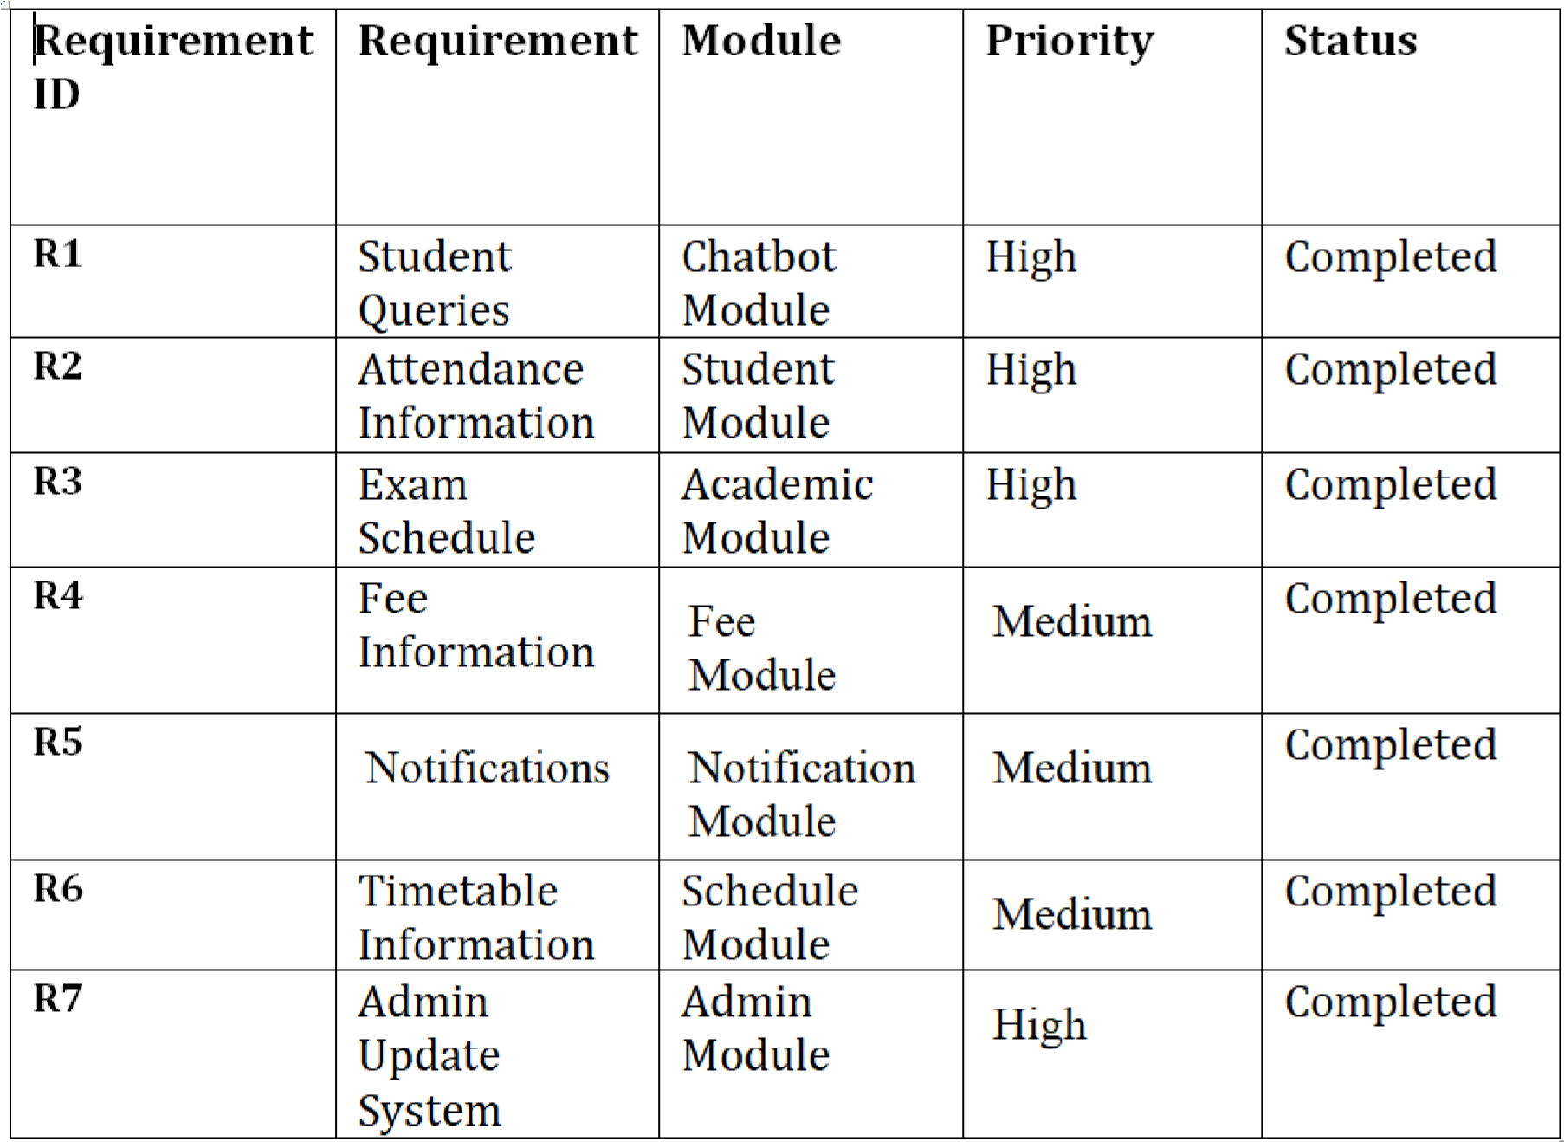

11. System Features
- AI Chatbot Support
The Smart Campus System provides an AI-powered chatbot that helps students by answering their academic and campus-related queries automatically. Students can interact with the chatbot at any time and receive instant responses without visiting university offices.
Main Functions
  - Answer student questions automatically
  - Provide quick responses
  - Support 24/7 communication
  - Reduce manual workload on staff

- Attendance Management Feature
The system allows students to check their attendance information through the chatbot. This feature helps students monitor their attendance records easily and saves time.
Main Functions
  - Display attendance percentage
  - Show subject-wise attendance
  - Provide updated attendance records
- Exam Schedule Management
This feature provides students with complete exam-related information including exam dates, timings, and schedules. Students can quickly access exam details through the system.
Main Functions
  - Display exam schedules
  - Show exam dates and timings
  - Provide updated examination information
- Timetable Information System
The timetable feature helps students view their class schedules and academic timetable easily. Students can access timetable information anytime through the chatbot.
Main Functions
  - Display class schedules
  - Show lecture timings
  - Provide timetable updates
- Fee Information Feature
The system provides fee-related information to students. Students can check fee status, deadlines, and important payment announcements through the chatbot.
Main Functions
  - Show fee details
  - Display payment deadlines
  - Provide fee notifications

- Notifications and Announcements
The system sends important notifications and university announcements to students. This feature improves communication and ensures students receive updates on time.
Main Functions
  - Send academic notifications
  - Provide university announcements
  - Deliver reminders and updates
- Admin Management Feature
The admin management feature allows administration staff to manage and update system information. Admin can control announcements, schedules, and academic records within the system.
Main Functions
  - Update academic information
  - Manage notifications
  - Maintain system records
  - Monitor chatbot activities
- User-Friendly Interface
The system provides a simple and easy-to-use interface so students and staff can use the chatbot without technical difficulties.
Main Functions
  - Simple navigation
  - Easy chatbot interaction
  - Quick access to information
- Secure Information Management
The system ensures secure handling of academic and student information to maintain privacy and reliability.
Main Functions
  - Protect user information
  - Maintain data security
  - Ensure reliable system access

11. Conclusion
The Smart Campus System (AI Chatbot for Student Queries) is an innovative AI-based solution designed to improve communication and student support services in educational institutions. The system provides fast, automatic, and accurate responses to student queries related to attendance, exams, schedules, fees, and announcements.
The project reduces manual workload on university staff, saves time, and improves the overall student experience through smart digital services. The requirement engineering process helped identify practical and important system features that meet user needs and project objectives.
The final SRS document clearly defines the system scope, requirements, user needs, and project functionality, providing a strong foundation for successful system design and implementation.

